2.1 Task 1 create new DB
1. Creating + connecting test_db DataBase
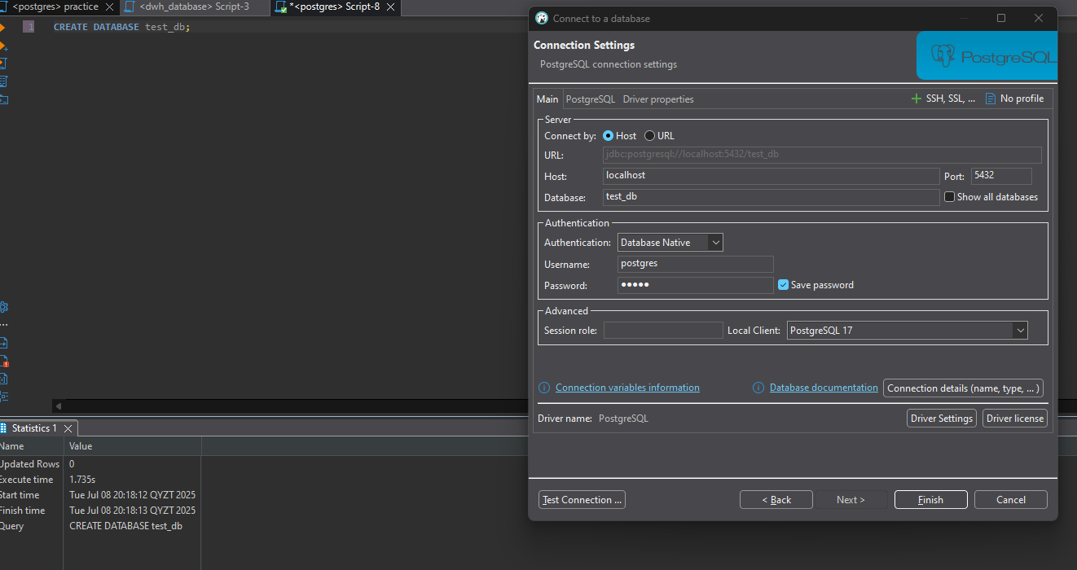
2. This query returns all database IDs along with their details and the name of the tablespace where each database is stored.
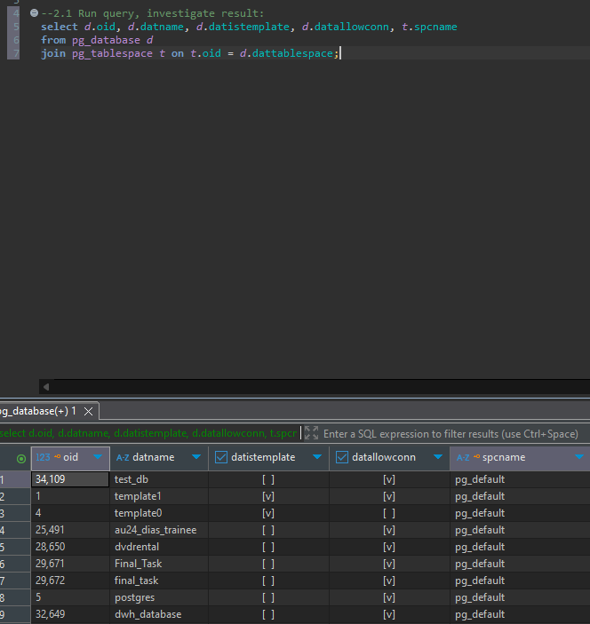
2.2 TASK 2 CREATE NEW TABLESPACE
1. Created folder tblspc_test in data dolder
2. Created TABLESPACE in my posgtresql direction
3. checked if it exists
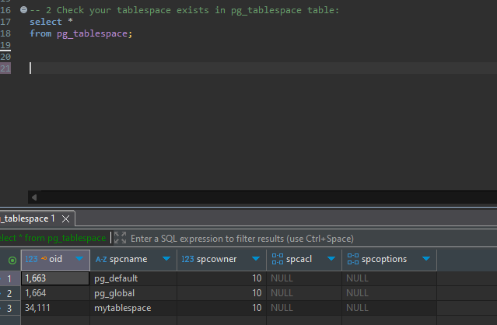
4. Then changed tablespace of test_db DATABASE with alter command
5. Checked if test_db’s tablespace was altered to ‘mytablespace’
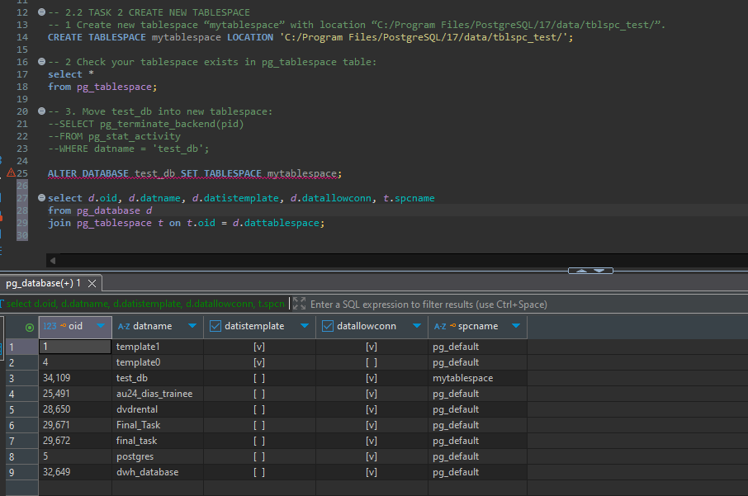
2.3 TASK 3 CREATE NEW SCHEMA
Before set pathh
Schema labs, table labs.person was created.
Insertions give error because we did not define schema for tables.
Search_path now = public(there was something else smth like public, public,”user”, but I changed it firstly and did screeshot)
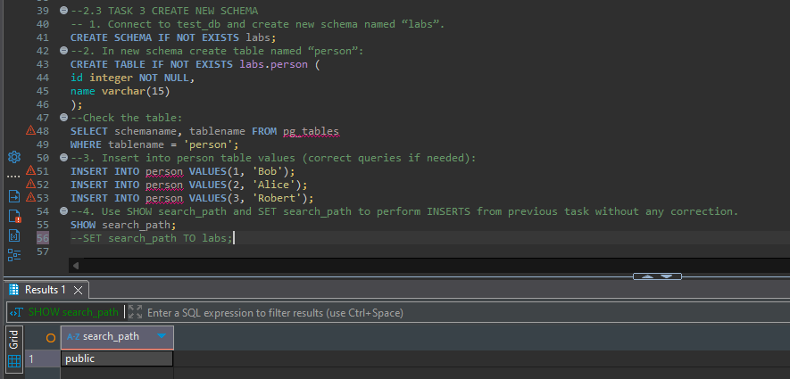
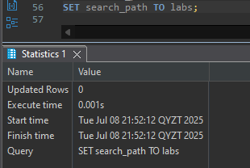
After set search_path to labs
It changed default schema from public schema to labs schema
And inserted values without errors
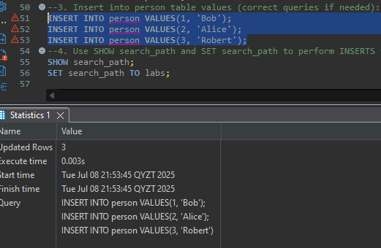

3.1 TASK 4 INVESTIGATE MVCC*
1st select
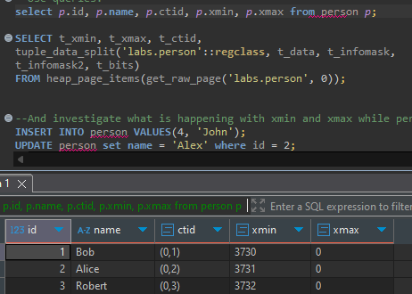
2nd select
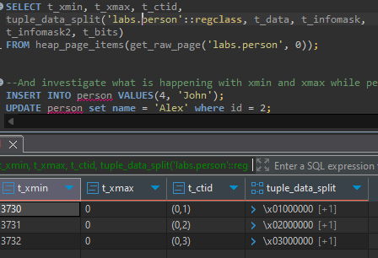
AFTER INSERT INTO person VALUES(4, 'John');
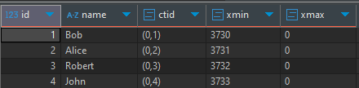
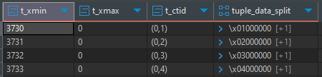
AFTER UPDATE person set name = 'Alex' where id = 2;
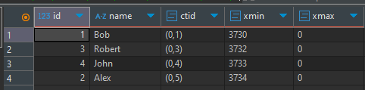
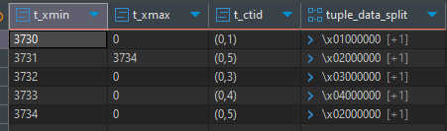
AFTER DELETE FROM person WHERE id = 3;
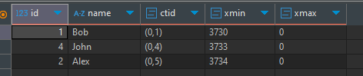
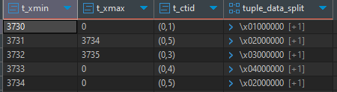
AFTER INSERT INTO person VALUES(999, 'Test');
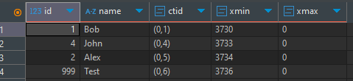
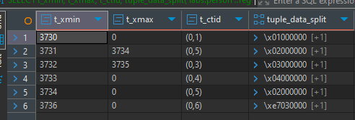
AFTER DELETE FROM person WHERE id = 999;
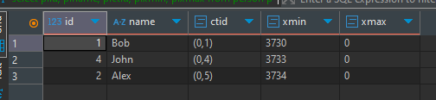
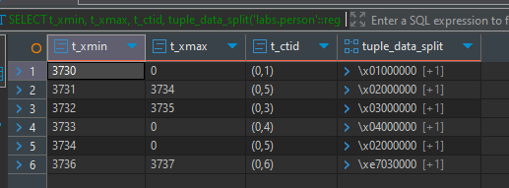
So, MVCC do not delete row permanently, we can inspect it by defining t_xmin and t_xmax with pageinspect extension we can see them at physical layer.
t_xmin is first transaction when data was inserted, while t_xmax is last transaction with this row after update or delete
With update we get new t_xmin for new row and previous row get t_xmax/ For example:
After UPDATE person set name = 'Alex' where id = 4; update = delete + insert
t_xmin t_xmax
3731 3734
3734 0
But, after delete we get only t_xmax for deleted row
DELETE FROM person WHERE id = 3;
t_xmin t_xmax
3732 3735
Inser gives us only t_xmin
t_xmin t_xmax
3730 0
--3.2 TASK 5 INVESTIGATE VACUUM
Initial state before any vacuum (I did some tests)
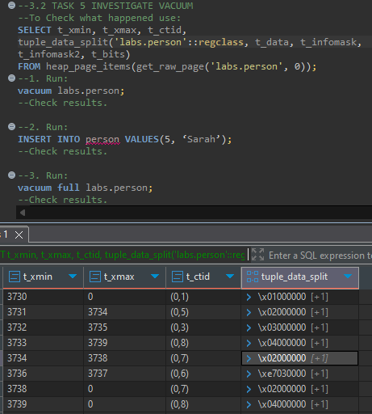

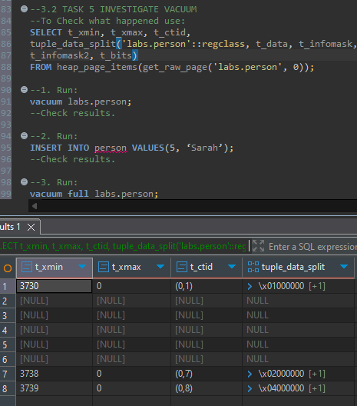
After 1st run with a simple vacuum, we get dead rows (NULL ones) and mark them as reusable. Dead rows becomes dead rows after delete or update not after vacuum.

After 2nd run: 1 of dead rows was reused
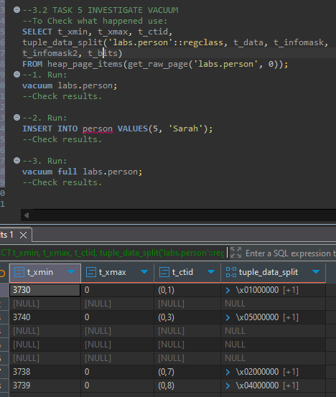

After 3rd run: vacuum full deletes all dead rows and updates ctid
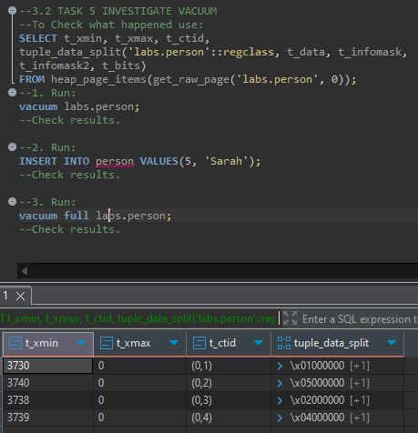
Vacuum is lightweight and enables reuse, but leaves rows on disk.
Vacuum full is heavyweight, physically removes garbage.

